Servlets are modules of Java code that run in a server application

A Servlet does not run in a separate process.
There is only a single instance of a servlet which answers all requests concurrently.
Don't need to worry about memory leak or garbage collection, which helps you write robust applications.

A Servlet stays in memory between requests.

Support of https and SSL
resides at server side and generates dynamic web page

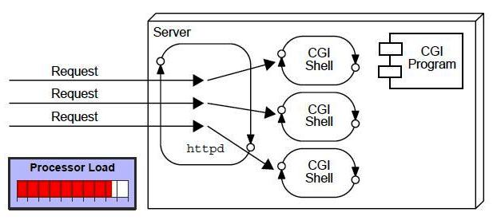

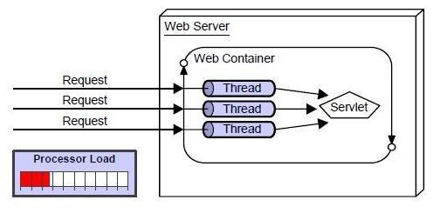

SERVLETS

Servlet :-a java class used to extend the capabilities of a server.
Servlets can respond to any types of requests but they are commonly used to extend the applications hosted by web servers.

Static :- only web browser, x dynamic, static Ex. SOP DATE

Communication between Browser and server :-

Before(Applets) :- Program output directly embedded into web pages.
browser point to web page and then create reference to applet and byte code downloaded to browser and then executed, (OK for thin but for large heavy)

CGI :- standard for communication between application to server. Each req. dynamically by creating separate process for each req.-loading
Cannot read and set HTTP headers, handle cookies, tracking sessions. Servlets is inexpensive than CGI.

Applets :- Dynamically extends capability of WEB BROWSER
Servlets :- Dynamically extends capability of WEB SERVER
Small programs that run on server side of web connection(like, server side applets)
Not tied with specific client server protocol but most commonly used with HTTP.
:P Applets that run on servers instead of in web browsers.

DIAGRAM 1(SOURCE OF SERVLET)(REMOTE/TRUSTED)

Generic SL :- main class
must invoke service()
Client-->Webserver-->req,s<--Generic SL-->service()
HTTP SL :- Inherited from generic, all properties
Client-->Webserver-->req,s<--httpSL and selected methods i.e. Doget, post, trace, put

No main method
The life cycle of a servlet is controlled by the container in which the servlet has been deployed. When a request is mapped to a servlet, the container performs the following steps.
If an instance of the servlet does not exist, the Web container
1. Loads the servlet class.
2. Creates an instance of the servlet class.
3. Initializes the servlet instance by calling the init method.
Invokes the service method, passing a request and response object.

DIAGRAM (notebook):- How container handles the request

Life Cycle :- init() service() destroy() (Box Diagram 7)

init() :- only once in whole, not repeated,

service():- HEART, invoked for each client, each request runs in separate thread

destroy() :- for each client, can be overridden
Generated content is generally HTML or XML
terminates particular SL,
once for container, many times for user

+ves:- Secure communication between Web server and servlet(XML),
JSP Support, to add dynamic control from server side uses HTTP Protocol
Inexpensive, Portable

WORK:- read explicit data from client i.e. form data
read implicit data from client i.e. Request headers
Generate results
Send explicit data back to client i.e. html
Send implicit data back to client i.e. dogetpost overridden to provide desired behavior

Application :- cookie, session tracking(generate/maintain session of req frm usr 4 time period ),
Lifecycle Management, Multithreading

Coding Portion :- class import > javax.SL, n .http
extend HTTPSL class

2 objects, httpservletreq n httpservletres

httpslreq. :- allow SL to access info such as :- name of param, protocol, name of HOST which made request
httpslres:- to reply, response, allow SL to set content length, a writer through which SL can rep to WB.

Set content type :- text/html → to tell SL/Browser k HTML code

WEB-INF Folder –> web.xml (defines SL used in application, maps SL to URLs)

WEB.XML :- mapping, SL Name, Session Timeout, cookie management

Extra

Serializable interface is used to create classes which
enable the transfer of any binary object over a
communication channel by transferring all the data of the
object in a byte by byte manner.

JRE includes (JVM ) java virtual machine and some other library files. That runs a java application.JVM - understand the corresponding byte code of a java class and make it ready for run.
advantage of servletconfig interface is that you don't need to edit the servlet file if information is modified from the web.xml file

serialization an object can be represented as a sequence of bytes that includes the object's data as well as information about the object's type and the types of data stored in the object.

What is meant by Asymmetrical protocols?
There is a many-to-one relationship between clients and server. Clients always initiate the dialog by requesting a service. Servers are passively awaiting for requests from clients.

Web containers :- interacts with web servers and java servlets

status codes :- description of corresponding methods it can follow and any meta information required in the response.

CGI platform dependent
Servlet platform independent

